Mineral Resources – Chapter 14

* Renewable and Non Renewable
* Renewable – available in unlimited supply, and not concentrated – energy resources such as hydro, geothermal, tidal, wind and solar power. Clean resources …
* Non renewable – available in finite supply and come in concentrated form – minerals, oil, gas, coal etc. “Dirty” because processing and use produces pollutants
* Recycling is reuse of a resource such as metal, glass, paper, plastic etc.
* Recycling extends the useful “life” of a non-renewable resource such as aluminum.
* Recycling only works if it more economical to recycle the old products than produce new products and if there is enough to recycle.
* Earth contains elements and materials that are useful to man. Gold, Silver, Iron, Copper, Cadmium, Chromium, gravel, sand, limestone, granite countertops etc..
* Elements (silver, copper etc.) occur in low concentrations in earth’s crust, but are concentrated by earth processes. Igneous rocks contain these resources.
* Example: Earth’s crust contains enough silver to sustain our needs for millions of years, but silver is only concentrated in a few locations currently representing a supply that will last 20 years. We use about 10 K metric tons/year.
* Sand and gravel are also concentrated in certain locations by sedimentary earth processes. At or near the surface. Lake Bonneville, river terraces etc.
* Limestone is used to make concrete and in manufacturing. Limestone is very plentiful in the USA and is a sedimentary rock. Some places (Japan) limestone is not as plentiful. Depends on geologic origin.
* Salt plentiful in Utah – Morton and GSL

Geologic Origin of Minerals

* Igneous rocks form from magma that originates deep inside the earth at high heat and pressure.
* Rock defined as aggregate of minerals.
* All magma contains small concentrations of lots of precious metals/minerals, but these minerals are only concentrated under certain geologic conditions.
* Since it originates inside earth, most minerals are in old rock that has been lifted up by faulting
* Plate tectonics and origin of magma – convergent and divergent boundaries
* Lava extrusive, basalt, andesite, small (can’t see) crystals
* Pyroclastics extrusive, ash cinders, obsidian and “tuff”
* Intrusives – Granite, gabbro, made of large (can see) crystals (gold, copper, lead, zinc silver)

Gold Deposits and Origin

* A disseminated deposit is a geologic body in which the ore mineral is scattered throughout the rock in low concentrations.
* The concentrations are adequate to make the mineral deposit an ore deposit, i.e. it can be mined profitably under current market conditions. Ore grades are low, a few ounces per ton processed. Many of these types of deposits are very large with maximum dimensions measured in 10s of kilometers.
* Disseminated deposits are formed by a variety of geologic processes and often contain very large amounts of ore. Gold, copper, molybdenum as well as many other metals are produced from disseminated deposits.
* Hydrothermal mineral deposits are formed by a process involving the dissolving, transportation, and precipitation of metals in hydrothermal fluids.
* These deposits can form at or near the earth's surface or they can form deep in the crust and show distinct characteristics based on the depth of formation.
* Each mineral deposit shows distinct characteristics which are controlled by the type of mineralizing fluids, type of host rocks and the solubility of the elements of interest.

Placer Deposit

* Gold erodes from larger igneous parent deposit (mother lode)
* Eroded material deposited in stream beds and rivers (gold is heavy)
* Environmentally destructive, but does not require chemical processing
* Iron from rocks over 2 billion years old. Banded Iron formations
* Formed when earths atmosphere and oceans much different. Does not generally form today widespread (North central USA)
* Bauxite is the ore of aluminum
* Sedimentary process, including long periods of weathering

Non renewables and sustainability

* Amount of resource is finite (non sustainable)
* Can find alternatives (silver is gone from the photo industry)
* Glass fiber instead of copper
* Recycling
  + 50% plus of iron - $18.5 billion
  + 50% Aluminum - $10 billion
  + 30% Copper
  + Recycling saves on production, waste and use of other resources

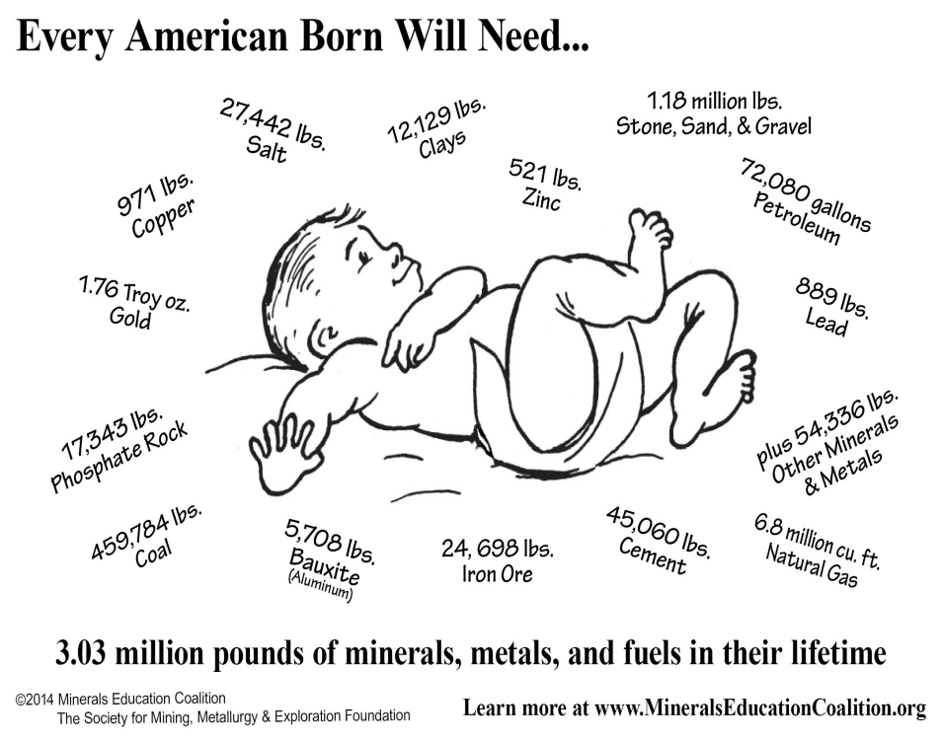

* Amount and type of waste depends on product and local conditions
* Processing uses large volumes of acids and other chemicals
* Giant volumes of tailings (crushed rock) and slag (smelted and processed)
* Kennecott, pit, tailings, tailings pond and slag
* Mining companies report waste rock as waste to shareholders, but mining industry does not publicly say waste rock is mine waste.
* Waste rock dumped by the mining industry in the United States alone contains hundreds of millions, if not billions, of pounds of toxics
* In some cases it could be a hazardous waste and the dust and drainage is toxic
* Opened in 1967 to extract metals, including copper, lead and zinc, abandoned in 1975.
* Waste rock and a pond of 100,000 cubic meters of very acidic, sulphide-rich, tailings (acid dissolves metals)
* Risk the tailings mass would liquefy in an earthquake or fail in an extreme weather event and flow down the mountain.
* Tailings dam has been stabilized and 110,000 cubic meters of old mine tailings have been treated and stabilized. $22 million
* The water quality of Tunakohoia stream has improved and there is no longer threat to health.

Mining in South America

* Mining is not “the key,” but could play an important role in mineral-rich countries’ development. Everything depends on the “rules of the game.”
* Since the early 2000s, mining has fueled growth. Many conflicts associated with the expansion of mining are, in fact, about the distribution of the benefits, in part due to national and local governments’ weak capacity to accountably invest their mineral rents in social development.

Mineral criticality and risk

* <http://dels.nas.edu/resources/static-assets/materials-based-on-reports/reports-in-brief/critical_minerals_final.pdf>